# Request for Proposal (RFP)

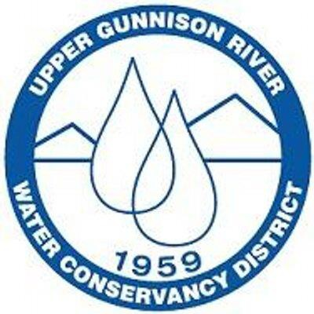

**Wetlands Mapping, Historic Wetlands Loss, and Wetlands Risk Assessments**

**For the**

**Upper Gunnison River Water Conservancy District**

**February 17, 2023**

The Upper Gunnison River Water Conservancy District (District) is pleased to solicit responses from qualified consultants to a Request For Proposals (RFP) for wetland assessment services (issued on a Task Order basis). The District anticipates consultant support on projects in three technical areas as described in Section 1, Scope of Work. The RFP submittal requirements, evaluation criteria and form of agreement are provided in Section 2, 3, and 4, respectively.

#### 1.0 Background

The District was established in 1959 by a vote of the taxpayers pursuant to the *Water Conservancy Act* to conserve, protect, and defend the waters within the Upper Gunnison River Basin. The District is governed by a board of eleven directors and staffed by its General Manager, General Counsel, Administrative Assistant, and Water Resource Specialists. Our mission is to be an active leader in all issues affecting the water resources of the Upper Gunnison River Basin. The District website provides additional detail and can be found at: [www.ugrwcd.org](http://www.ugrwcd.org)

The upper Gunnison River watershed is geographically located in west-central Colorado in the headwaters of the Gunnison River Basin, upstream of Blue Mesa Reservoir. The mainstem of the Gunnison River which forms at the confluence of the East and Taylor Rivers in Almont, picks up other tributaries on its way into Blue Mesa Reservoir. Seven tributary mountain watersheds make up most of the Upper Gunnison River Basin. These seven are Gunnison River Mainstem, Ohio Creek, East River which includes the Slate River, Taylor River, Tomichi Creek which includes Quartz Creek, Cochetopa Creek, Lake Fork of the Gunnison and Cebolla Creek (Figure 1).

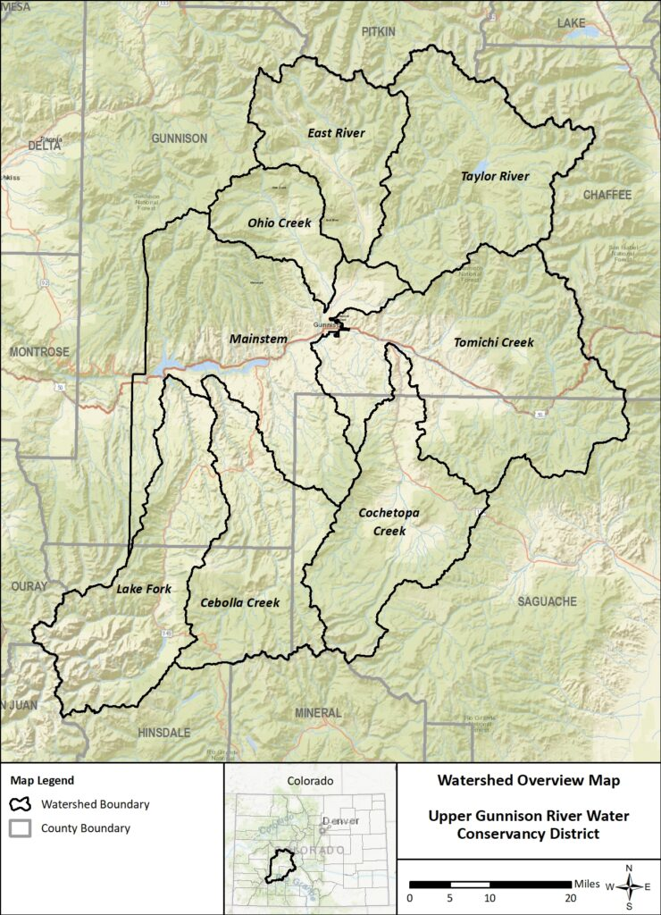Riparian areas and wet meadows within the Upper Gunnison Basin provide critical brood-rearing habitat for the federally-listed Gunnison sage-grouse and are also important habitat for neo-tropical migratory birds, big game, and provide forage for domestic livestock. However, many wetlands, wet meadows, and riparian areas are degraded by various land uses resulting in channel down-cutting and lowered water tables. In addition, many areas within the basin are likely to be further impacted by increasing severity and frequency of drought, increased erosion due to intense runoff events, and invasive species associated with our changing climate. This degradation is likely to result in a changed and diminished hydrology and land conversion due to aridification.

To address these challenges, the Upper Gunnison Basin Wet Meadow & Riparian Resiliency-Building Collaborative (Collaborative) is working to enhance ecosystem resilience of riparian areas and wet meadows by restoring hydrologic and ecologic function. Our goals are to address erosion across the landscape, restore groundwater

holding capacity, support the Gunnison sage-grouse and other wildlife and plant dependent species adapt to a changing climate, support the livelihoods of local ranchers who depend on healthy grazing lands, and ensure a healthy and functioning watershed for all residents and visitors who enjoy recreating in our basin. The Collaborative is using a variety of restoration methods designed by restoration experts Bill Zeedyk, Zeedyk Ecological Consulting, and Shawn Conner, BIO-Logic. These methods help slow down water during flow events, raise water tables and increase groundwater storage, reduce erosion and stabilize head cuts, reduce impacts of elk and cattle trailing, reconnect channels to floodplains, reduce wildfire risk and increase wetland plants and insects. For more information, access our webpage at: <https://ugrwcd.org/wet-meadows-program/>

Over the next year, the District will be working with our general public, state and federal agencies, and not for profit entities in our basin to identify and understand current wetland areas, historic wetland loss and wetland risks for protection or potential restoration.

#### RFP Schedule

|  |  |
| --- | --- |
| February 17, 2023 | RFP published. |
| March 15, 2023 | Cut-off date for submitting questions electronically to the District, [ccwelich@ugrwcd.org](mailto:ccwelich@ugrwcd.org) by 4:00 p.m. |
| March 24, 2023 | Response to questions. |
| April 7, 2023 | RFP and Fee Schedule due electronically in PDF format (20 MB limit) to Cheryl Cwelich, [ccwelich@ugrwcd.org,](mailto:ccwelich@ugrwcd.org,%20) by 4:00 p.m. |
| April 24, 2023 | Board approval of selected consultant. |

Questions regarding this RFP may be addressed to ccwelich@ugrwcd.org.

**2.0 Statement of Purpose**

It is the intent of the District to solicit Proposals from a qualified consultant or consultant team with expertise in the technical areas of: wetland function, wetland mapping, evaluating historic wetland loss, and wetland risk assessment. Consultants may respond to one or any of the technical project areas. Consultant assessment will support other on-going assessment efforts, including but not limited to, Wildfire Zones of Concern, Source Water Protection and Geo-fluvial Hazard studies being conducted by the District in the Upper Gunnison watershed. Please note that project *implementation* will be accomplished through a separate and future Design-Bid-Build process.

**3.0 Project Proposal Requirements**

In general, RFP responses should address the following:

* Technical approach for the project;
* Scope of work;
* Schedule for performing the work, identifying major milestones, deliverables and delivery dates;
* Technical and managerial resources and expertise that the consultant will use to meet project requirements;
* Project-specific resumes of proposed key personnel who will perform work;
* Customer references;
* Capacity to accomplish the work in the required time; and
* Preliminary cost estimate to perform the work based on the proposed scope of work.

Final project scope, schedule and cost will be negotiated with the District upon contracting. Attachment A includes a sample of the District’s "Professional Services Agreement" which the selected consultant would be asked to enter into. Prospective consultants should review and become familiar with this document.

**4.0 General Scope of Services**

Consultant is expected to provide services in either one or any of the technical discipline area(s) identified and within the political boundary of the District. Consultant will be managed by the District’s Water Resource Specialist and Wet Meadow Program Coordinator, Cheryl Cwelich.

**REQUEST FOR PROPOSAL**

# Wetlands Mapping, Historic Wetlands Loss, and Wetlands Ricks Assessment Services

The objective of this work effort is to provide wetland mapping services related to assessing existing wetlands, historic wetlands loss and wetlands risk assessments. Wetlands include wet meadows, fens, seeps, marshes, bogs, swamps and other riparian areas. Consultant is expected to work in collaboration with the District and their Wet Meadow Partnership Collaborative composed of experts in restoration, wildlife management, hydrology, field monitoring and water rights, etc., as well as with interns to complete assessments.

Consultant will evaluate stream channels, field observations of stream flow, bank conditions and geomorphology and surrounding land use to promote resilient stream reaches. Consultant will provide hydrologic and hydraulic recommendations to improve ecological integrity of streams, including habitat, land and vegetation to enhance aquatic and terrestrial environments.

**1. Primary Objectives: Assess wetland, stream and riparian habitat conditions and provide recommendations for improving ecosystem health.**

* Maps showing extent of wetlands in the Upper Gunnison Basin;
* Assessment and mapping of areas where wetland or riparian loss have occurred;
* Assessment of anthropogenically-influenced wetlands including wetlands in mine areas, wetlands in irrigated areas, excavated wetlands, impounded wetlands, and drained wetlands;
* High-level assessment of wetland health in select wetland complexes;
* Original mapping to support current and future trajectories with regard to promoting public and private understanding of overall wetland health, loss and risks; and
* Documentation of more significant risks to wetlands.

**2. Anticipated Scope of Work**

**Task 1 – Wetland Data Compilation, Mapping & Historic Loss**

Utilize existing datasets to the extent practicable and provide an assessment of the quality of the data. Develop a comprehensive understanding of the existing and available data and information to identify data needs (gaps) that could inform the identification of the extent of current and historical wetlands within the Upper Gunnison Basin. Incorporate data from the following sources:

* USFWS National Wetlands Inventory (NWI) – including vegetation, hydroperiod, and hydrogeomorphic classes
* BLM data
* US Forest Service data
* USDA/NRCS irrigated lands LiDAR data, and other existing LiDAR data

These data sources could be used to help map and delineate the extent of wetlands in the basin, and where possible, to also help identify the historic extent of wetlands. In addition, review information from the following sources to determine if these other datasets could further help inform the extent of existing or historical wetlands, and the types of wetlands (such as fens):

* Rocky Mountain Biological Laboratory (RMBL) data
* The Nature Conservancy (TNC) data
* Colorado Natural Heritage Program (CNHP) data
* TNC, CNHP, Western Water Assessment and the University of Alaska, Fairbanks – 2011 Gunnison Basin Climate Change Vulnerability Assessment
* Colorado Water Conservation Board’s (CWCB) Wildfire Ready Watersheds Project (with Enginuity)
* Upper Gunnison River Basin Watershed Assessment and Management Planning Phase I (Ohio Creek, East River, and the Lake Fork of the Gunnison River Basin) 2019
* EcoMetrics – Functional Assessment of Colorado Streams and the Health Assessment Framework
* Inventory of Fens in Large Landscape of West-Central Colorado 2012.

In select areas (where evidence of wetland loss is notable), utilize historical aerial photos to help define areas of wetland loss, and provide shapefiles of where these areas occurred, and the type of wetlands which were lost. In addition to historical wetland loss, assess and analyze wetlands which have experienced significant anthropogenic influences (mining, irrigation changes, excavation, etc.).

**Deliverables**: ESRI shapefiles and/or file geodatabases and accompanying maps detailing the extent of existing wetlands, anthropogenically influenced wetlands, and areas of evidence of wetland loss. Technical memorandum summarizing the outcomes from the data and information review. This document will list and prioritize areas within each of the seven sub-basins that will be considered for ground-truthing (see Task 2).

**Task 2 – Wetland Boundary Adjustments (Ground Truthing) and Wetland Condition Assessments**

Based on the locations and wetland types, coordinate with UGRWCD to identify wetlands of interest and areas where ground truthing is warranted (such as areas with coarse GIS data). There may be large areas of wetlands in the basin with good information on their condition, or that these areas are not of interest. Based on identified wetlands of interest and in areas with coarse GIS data, contractor will conduct site visits to assess the wetland boundaries and wetland condition. A formal US Army Corp of Engineers (USACE)-approved wetland delineation would not be conducted, but rather a general mapping of the wetland boundaries (which would generally follow USACE criteria for hydric vegetation and evidence of wetland hydrology).

Contractor will also conduct an assessment of wetland condition and health, and document any wetlands of high importance, specifically:

1. Wetlands that contain known populations of Federal or State threatened or endangered species.
2. Wetlands that contain fens as singularly or jointly-defined by the U.S. Forest Service, U.S. Fish and Wildlife Service, and USACE. Contractor will reference CNHP’s Wetland Inventory Mapping Tool, Colorado River Basin Dynamic Wetland Mapper and Fen data to ensure non-duplicative efforts.
3. Wetlands that perform at a high level of functionality, are relatively undisturbed by humans, and possess a superior example of a particular wetland habitat type.
4. Wetlands that constitute in whole or in part a habitat type rare in the Upper Gunnison Basin (e.g., depressional wetlands, alpine wetlands).

Wetlands documented to be of high function, but that do not fulfill the criteria stated above, may also be of interest to the UGRWCD because of the important services they provide. These wetlands may be termed “wetlands of concern.” Wetlands of Concern for the purpose of this assessment as including the following characteristics:

1. Strong dominance of native species, with few non-native species or noxious weeds.
2. High species diversity, including a variety of wetland forbs, sedges and rushes, and willows.
3. Presence of histic soils (soils containing peat layers, but not developed enough to qualify as a fen).
4. Adjacent or abutting larger wetland complexes; sites that are not fragmented or isolated, and/or that provide important habitat and hydrologic connectivity within the larger landscape.
5. Minimal apparent degradation from previous anthropogenic disturbances.

**Deliverables**: The initial delivered shapefiles/geodatabases (see Task 1) would be updated, and changes/improvements would be tracked in the attributes to reflect boundary adjustments, wetland types, etc. Shapefiles of the wetland assessment points would be delivered to the District, with accompanying attributes detailing the results of the wetland health assessment. Corresponding data sheets and a summary table (in Microsoft excel) will be generated detailing the wetland assessment, along with site photographs.

**Task 3 – Wetland Risks/Threats Assessment**

Based on aerial interpretation of wetlands, and ground truthing exercises, identify areas where there are risks to the extent, function, and health of wetlands through stressors such as apparent drought, water diversions/infrastructure, fill (e.g., development and human influences), and headcutting/sidecutting or other dewatering actions. Data forms will be developed to document conditions and photograph the risks occurring to wetlands.

Coordinate with UGRWCD to ensure all other pertinent data or efforts have been reviewed and incorporated into the assessment. Initial review of other efforts include cross check efforts conducted by:

* JW Associates – Wildfire Assessment to Identify Zones of Concern
* Watershed Science and Design – Fluvial Hazards Assessment
* Trout Unlimited – Agricultural Assessment (infrastructure, irrigation water management practices)
* Applegate Group, Inc. – Agriculture Systems Optimization (irrigation water management practices)

# Deliverables: ESRI shapefile/database of points, lines, or polygons of wetland risk/impact areas, along with accompanying data forms. Summary of risks would be recorded as attributes in the shapefiles.