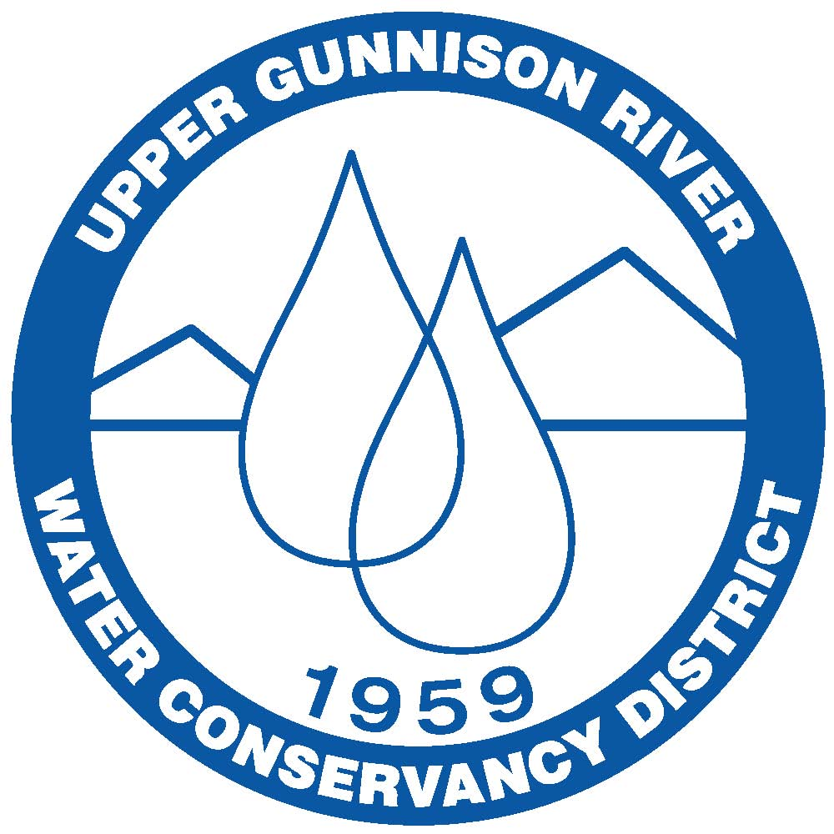

Upper Gunnison River Water Conservancy District
210 West Spencer Avenue, Suite B, Gunnison, Colorado 81230
(970)641-6065 • Fax (970) 641-1162 • www.ugrwcd.org

OUR MISSION: To be an active leader in all issues affecting
the water resources of the Upper Gunnison River Basin

EDUCATIONAL MINI-GRANT PROGRAM APPLICATION

Applicant Name:
Educational Organization (if applicable):
Applicant’s Affiliation with Organization (if applicable):
Organization Mailing Address:
City: | State: |  | Zip:
Phone Number: | Email Address:
Project Title:
$ Amount Requested ($500 max): |  | Total Expenditure for Project:
Other income?: |  | Estimated Number of Participants:
Projected Execution/Completion Date:
Please provide a brief description of the project:

Please describe how this project meets the goal of local water education/outreach:

Please provide a simple budget of expenses and income and what this Mini-Grant will pay for:

Signature of Applicant: |  |  |  | Date:
Supervisor or  other Reference  from organization if  Applicable: |  |  |  | Phone:

