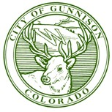

11th and Quartz – Upper Gunnison River Water Conservancy Grant – Final Report

The Xeriscaping 11th and Quartz Park is complete. The City of Gunnison worked with Alpine Landscapes to install drought resistant bushes and plants, installed decorative boulders, and five trees (one ponderosa, one juniper, one crabapple, and two chokecherries. We also brought in blue crushed granite, red crush granite, and large cobbles to fill the area out.

We are extremely grateful for the grant that the Upper Gunnison River Water Conservancy District provided so that we could accomplish this project.

Please let me know if you have any questions.

Sincerely,

Dan Vollendorf

Parks and Recreation Director

City of Gunnison

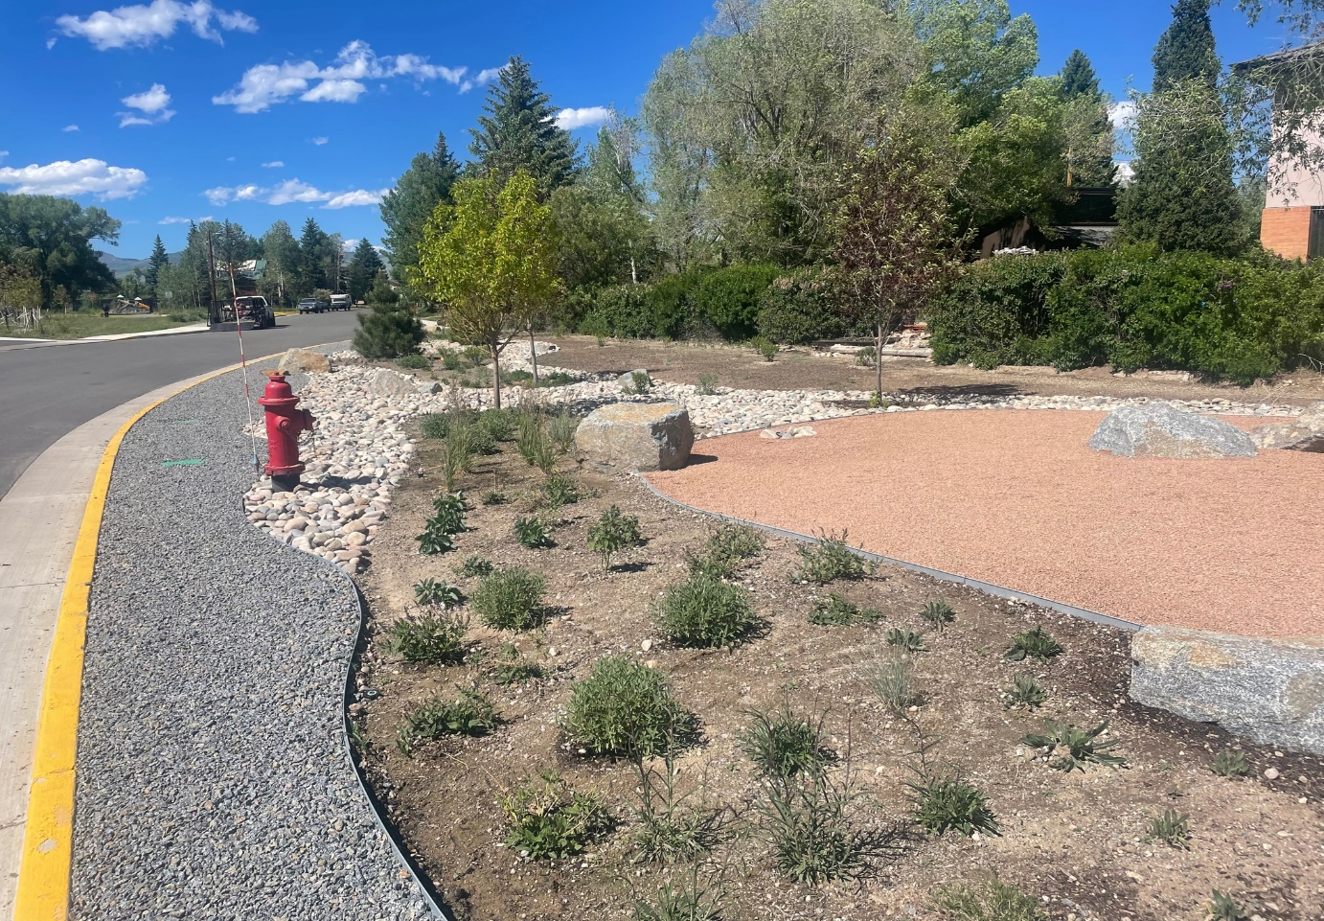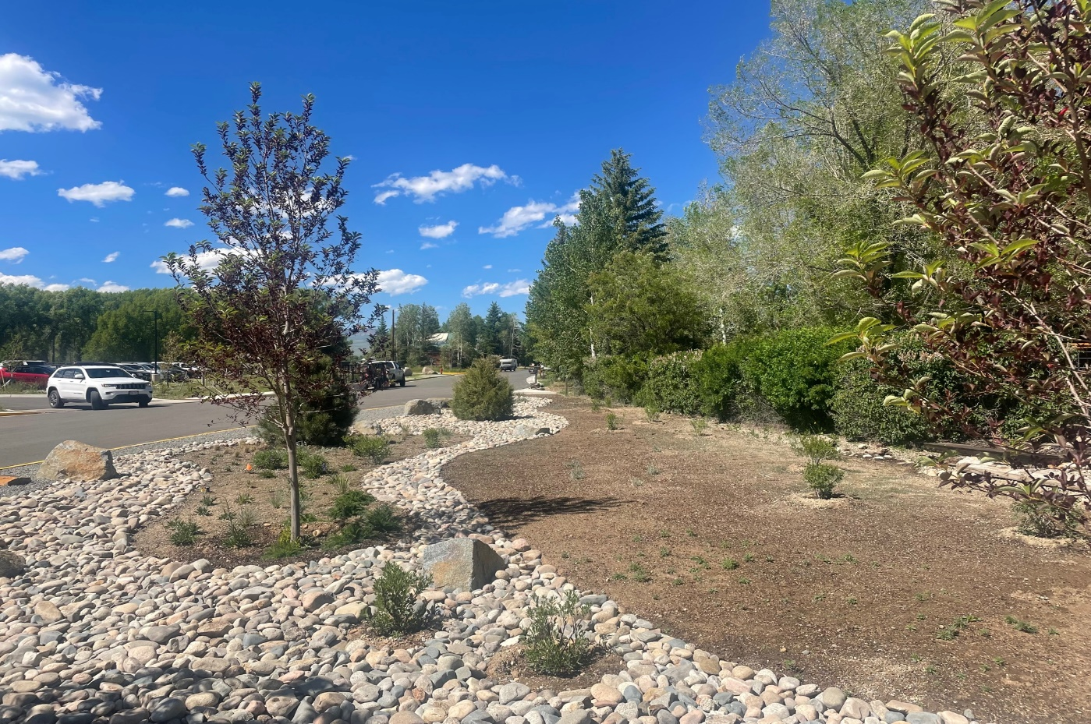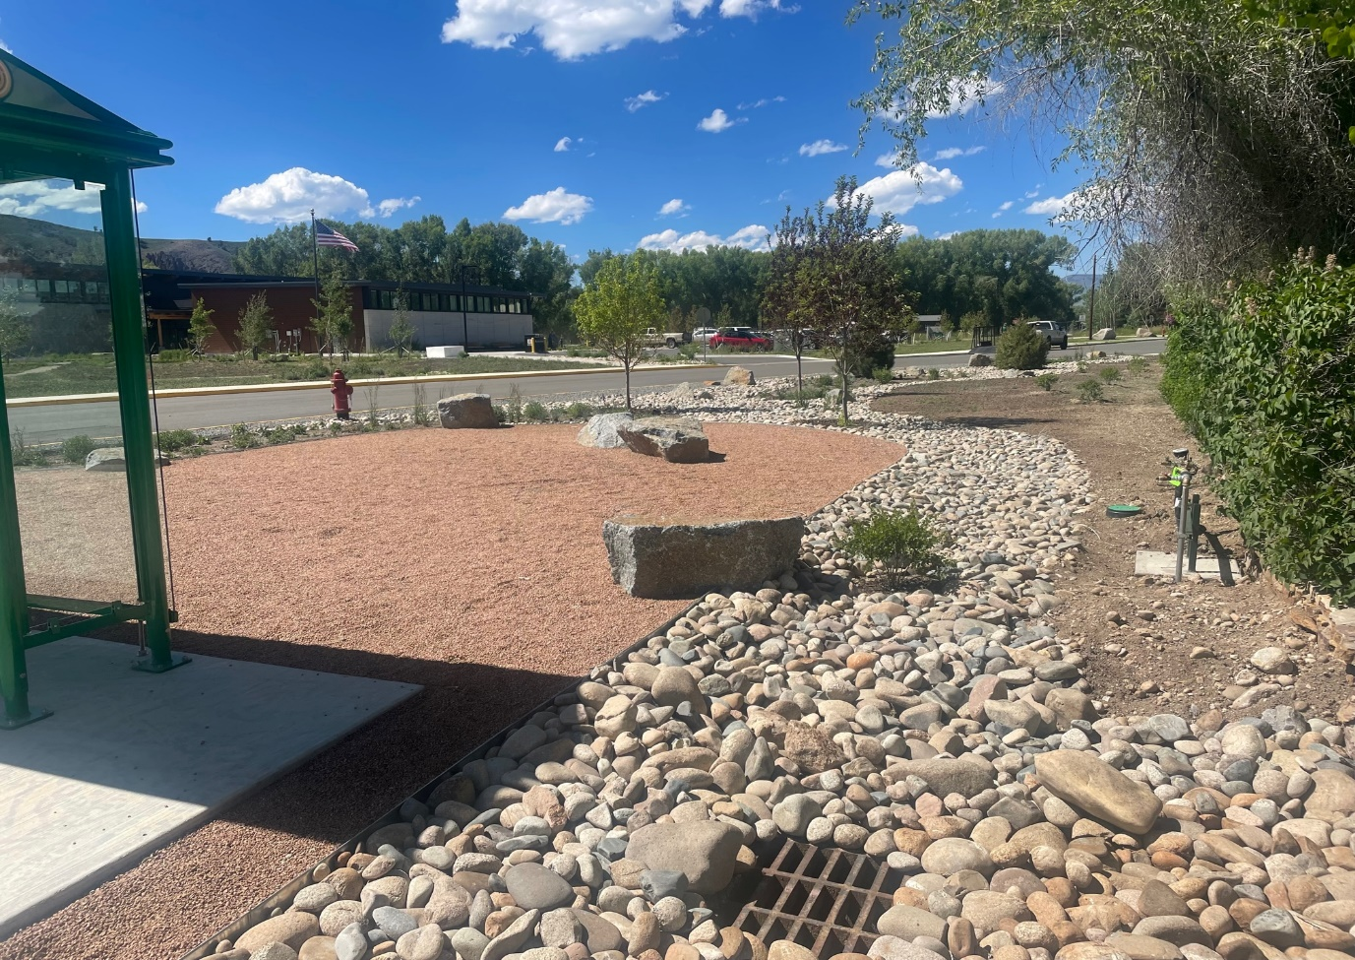

Following the realignment…

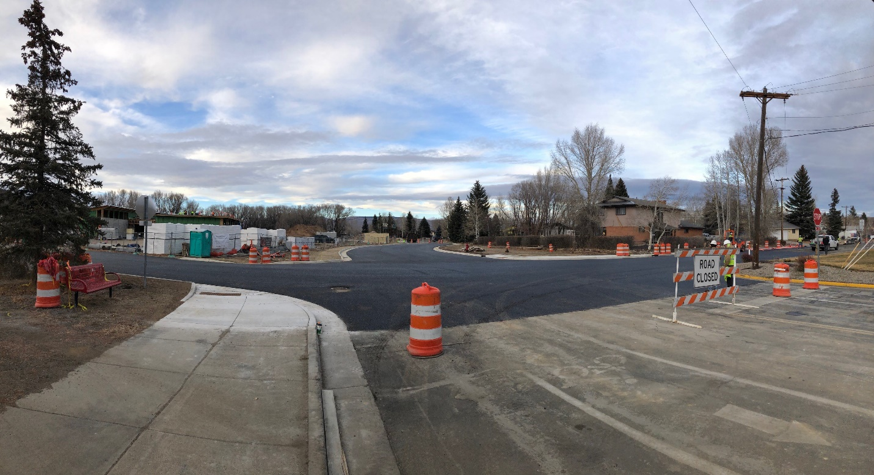

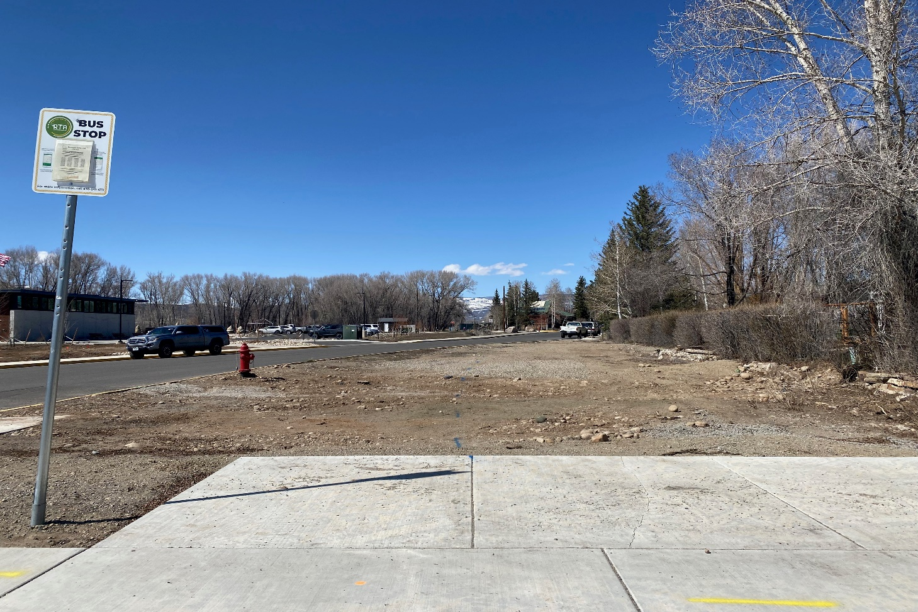

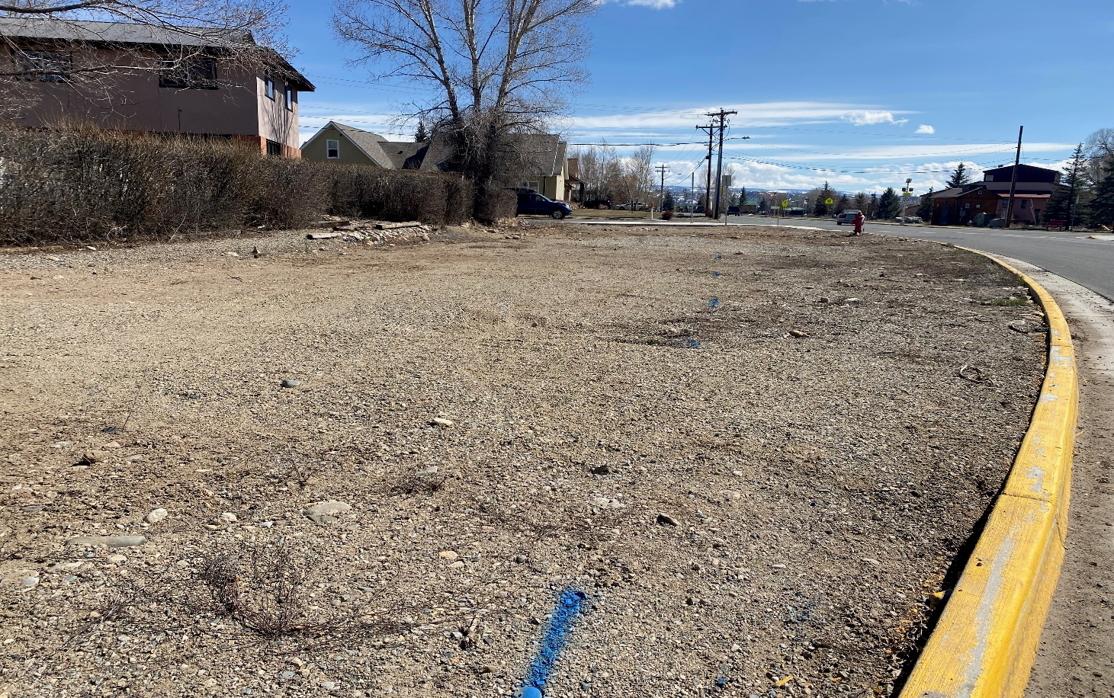

Before the realignment…

