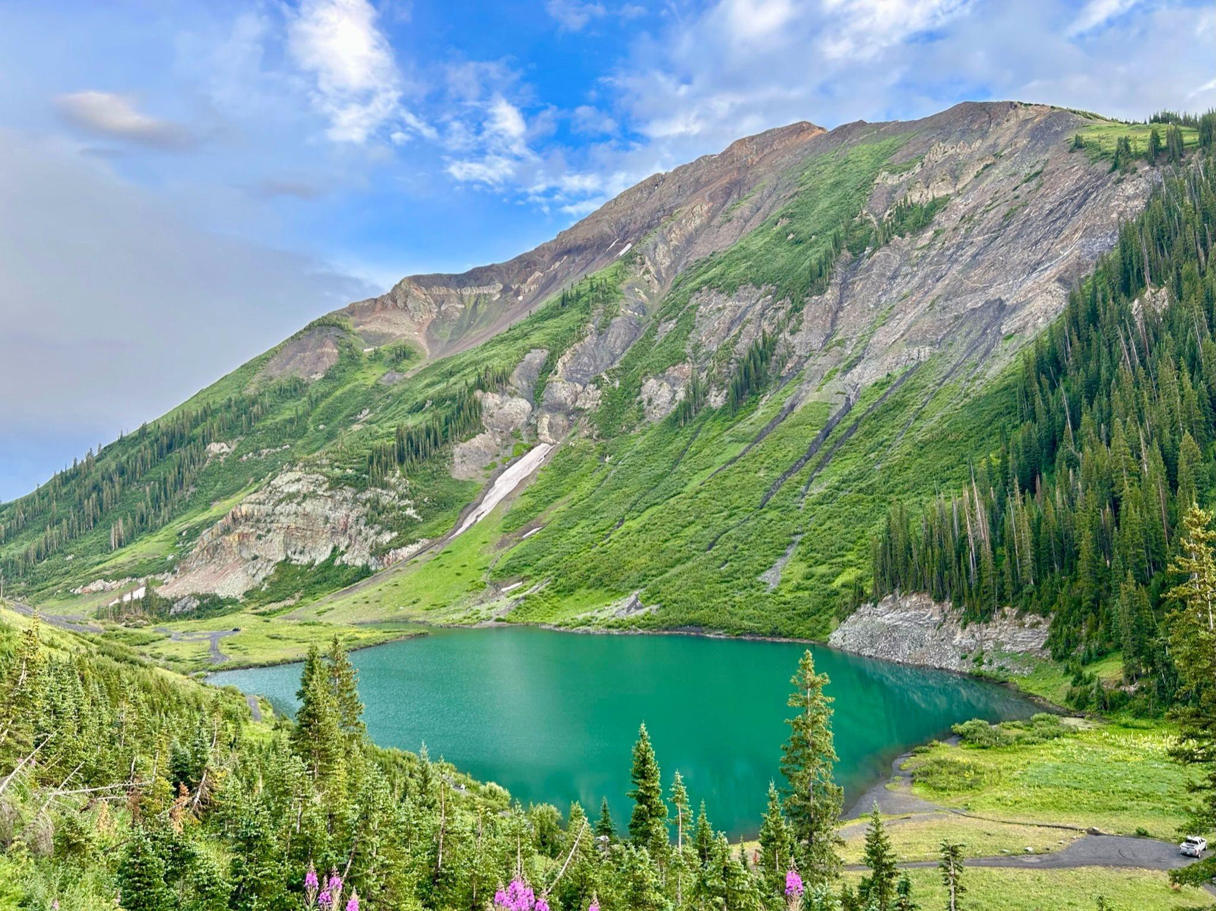

Upper Gunnison River Water Conservancy District 210 Spencer Ave STE B, Gunnison, CO 81230 Drought Contingency Plan Stakeholders Meeting March 27, 2024 from 9-11 a.m.

**Invitation:** Upper Gunnison River Water Conservancy District invites you to…

* Understand the Gunnison Basin vulnerability to drought.
* Share how drought affects you.
* Learn about the Drought Contingency Planning process and how you can be involved.

**RSVP:** Please respond to the form <https://forms.gle/8faiiAjHQjszYa23A> if you are able to attend. In person attendance is highly encouraged. Please reach out to Alana Nichols [anichols@ugrwcd.org](mailto:anichols@ugrwcd.org) with any questions. The Zoom link will be sent out prior to the meeting.

**Background:** The District was awarded a U.S. Bureau of Reclamation WaterSMART grant to develop a Drought Contingency Plan. A critical challenge to the communities within the District is planning and designing for resilience from the impacts of droughts with regards to sustainable management of resources.

The planning process will help the District to secure water resources, prepare for reduced risk of water shortages, and provide alternatives to build short- and long-term resilience to drought. The District intends to work with local water users, municipalities, industry, educational institutions, agricultural producers, recreationalists, and environmental/conservation groups throughout the planning process. Additionally, the District will leverage this project with other on-going planning efforts including municipal source water protection planning, identification of forest and wildlife zones of concern and critical infrastructure, watershed and stream management planning, wet meadow and riparian restoration, community wildfire protection planning, land use code updates, and community drought conservation messaging.

**Learn More:** Visit the District’s website to learn more about the process so far and find educational videos about water in the Gunnison Basin. <https://ugrwcd.org/drought-contingency-planning/>